Train – 90% test -10% most efficiency use train_test_split

matplot.lib for visualize in grp

csv file – read_csv

xml – read_xml

json – read_json

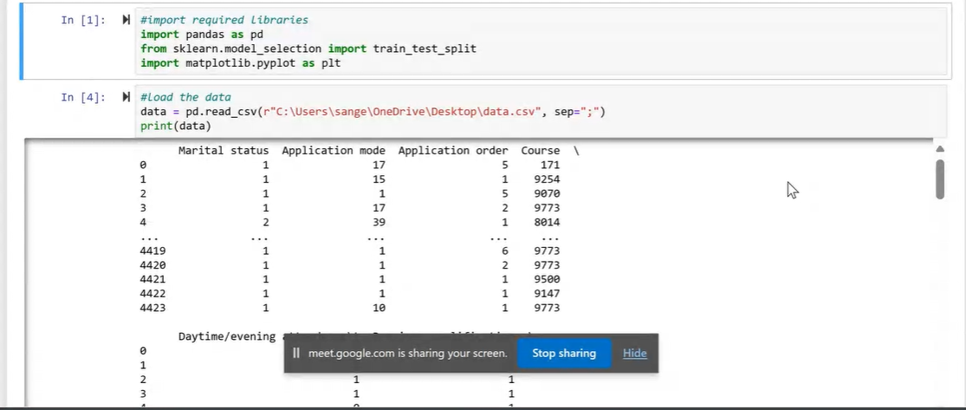

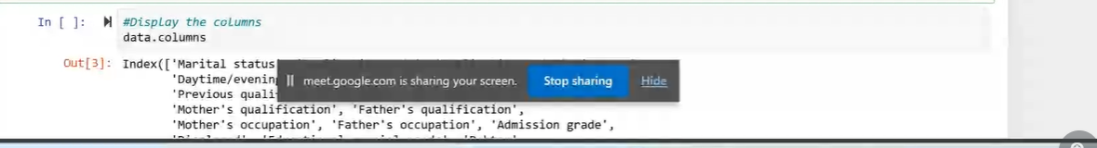

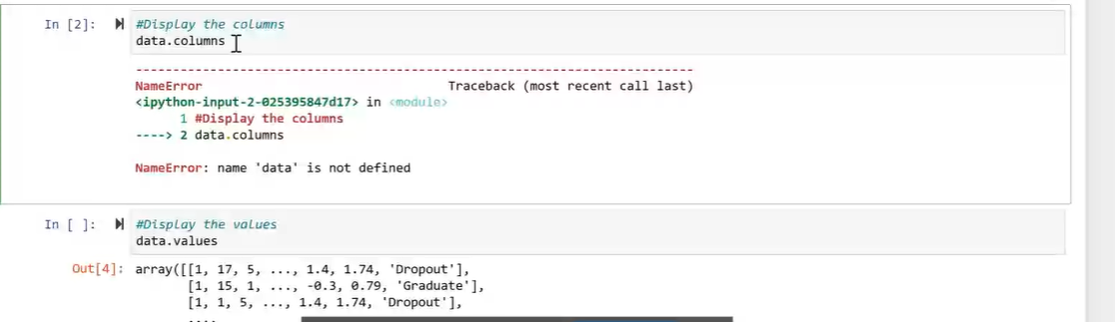

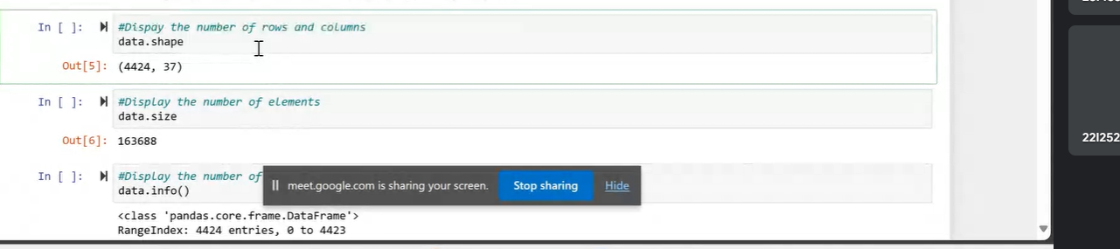

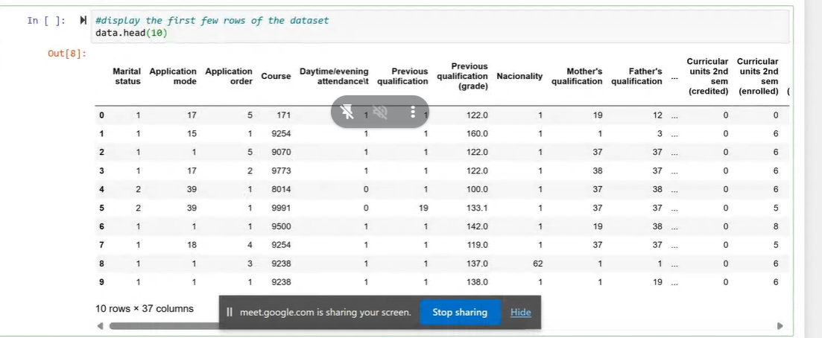

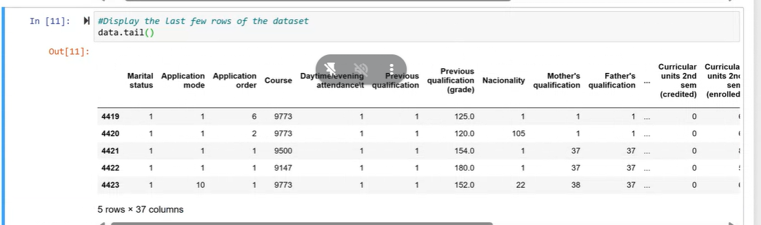

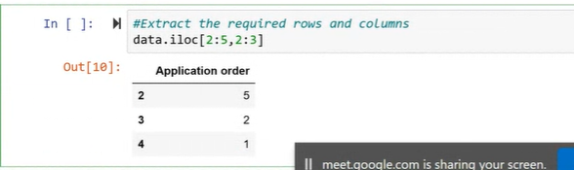

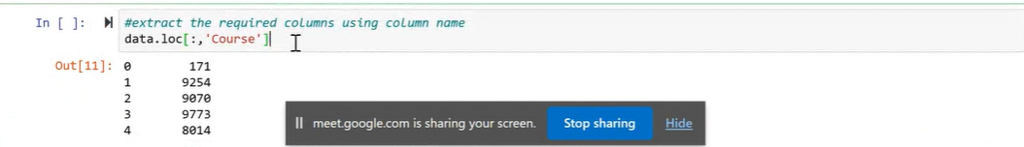

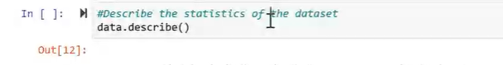

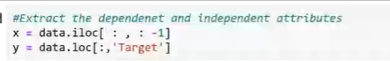

[::,:-1] EMPTY MEANS ALL

-1 means total -1

Target is the col name

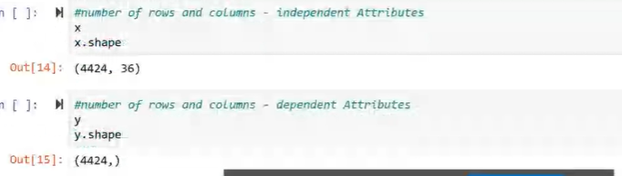

y.shape

(value, ) means

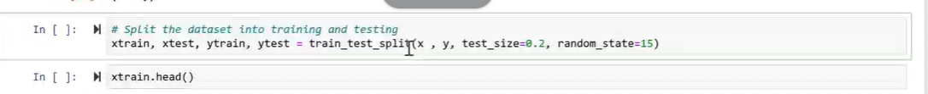

test_size or train_size can define any one for the partition of test and train

random selection – random_state

divide into x (ind) , y(dep) , test_size , train_size

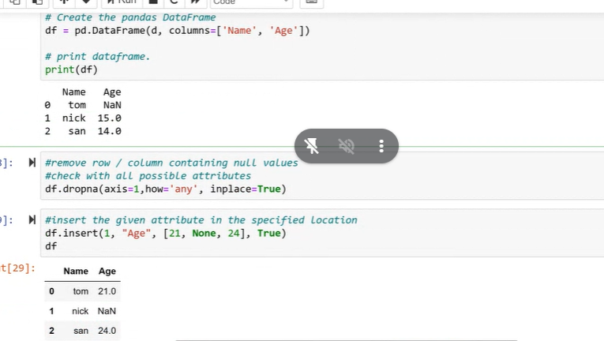

axis 1 col or axis is 0 row value

how- any none then delete

how – all only if all none then delete

inplace = true – del data completely even when we have slized and kept in another variable

insert:

(index,name of col, values for all rows, tell if duplication is possible or not{if true multiple values possible})



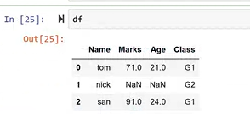

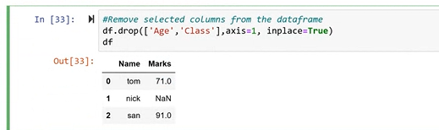

If the null values with mode,mean and median

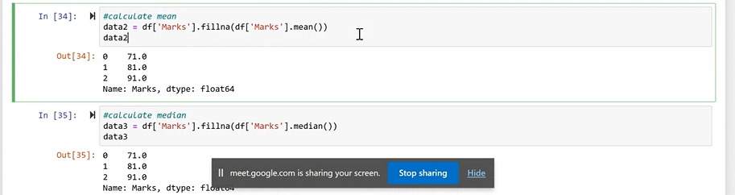



To determine how to fill the null values

